## **Biriyani Box**

* Website: <http://biriyanibox.com/> [ Using HTTP protocol which is insecure instead of HTTPS ]

HTTPS is more secure than HTTP. HTTPS is so important that Google uses it as a ranking factor in its organic search results.

* Page Load Time: 3.7 seconds
* Total Page Size - 3.49MB

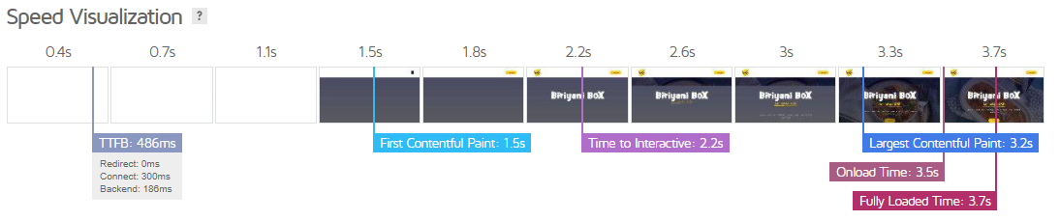

* Responsive:

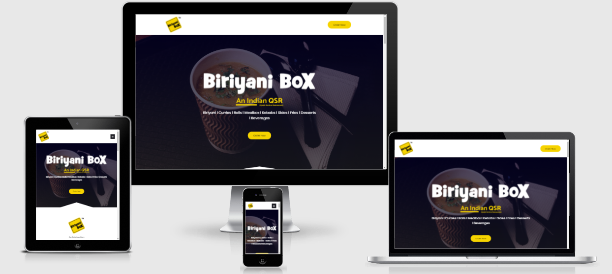

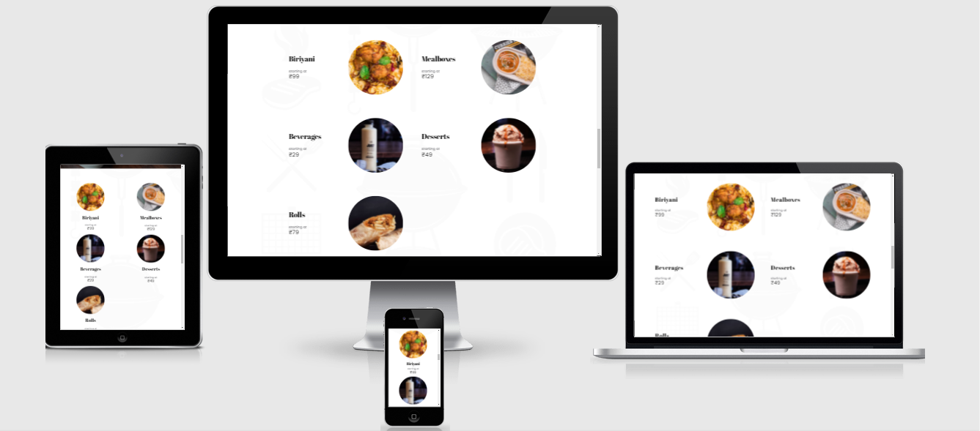

* Web Content

Less Content on the Website.

No Plagiarism

Errors:

* (ORIGINAL)

Biriyani Box is an **indian** QSR **modernising** the desi food in the global village with prompt, hygienic **and** **standardised** service.

* (MODIFIED ACCORDING TO GRAMMARLY)

Biriyani Box is an **Indian** QSR **modernizing** the desi food in the global village with prompt, hygienic**, and** **standardized** service.

* Social Handles
* **Facebook**

1. 2596 Followers.
2. 2,566 Likes
3. Creative Posts
4. Last Post : 26 Feb 2021
5. Posts on Trending Memes



1. Responds to Customers:

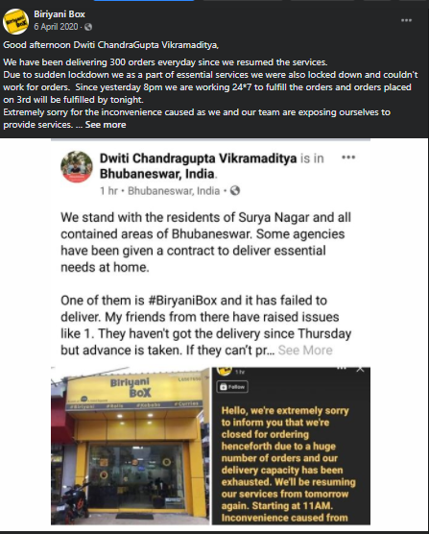

* Instagram:

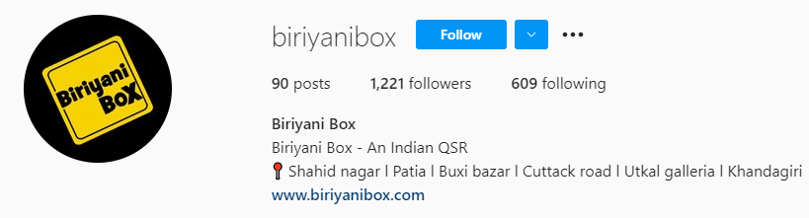

Last Post - April 8, 2021

Does Social Service